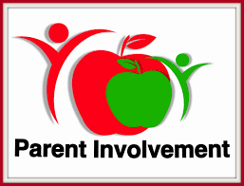

Dear Parents and Guardians:
We are excited about the school year and would love to have you become a member of our Parent Volunteer Program! Research tells us that parent involvement in a child’s education is one of the most important factors in raising student’s academic achievement and self-esteem.
Some of the duties you can assist with include making copies, filing, sorting, escorting students, chaperoning field trips, organizing or assisting with school events, serving as hall monitors, assisting with lunch duty, working in the media center and counseling center, and assisting with front office tasks.
Volunteering at least TWICE within a given month will also make you eligible for our Parent of the Month Program! Staff members will nominate ONE parent for this special recognition each month.

If you are interested in becoming a parent volunteer, please click here https://www.fultonschools.org/Page/899 .

For more information or questions, please contact Ms. Ortiz, Parent Liaison at 470-254-9382 or ortizb@fultonschools.org or Ms. Hammock, School Counselor/Family Engagement Facilitator at 470-254-9375 or hammocka@fultonschools.org.

We appreciate your support and look forward to partnering with you!

